Birthday Party Contract

Dance Studio 33
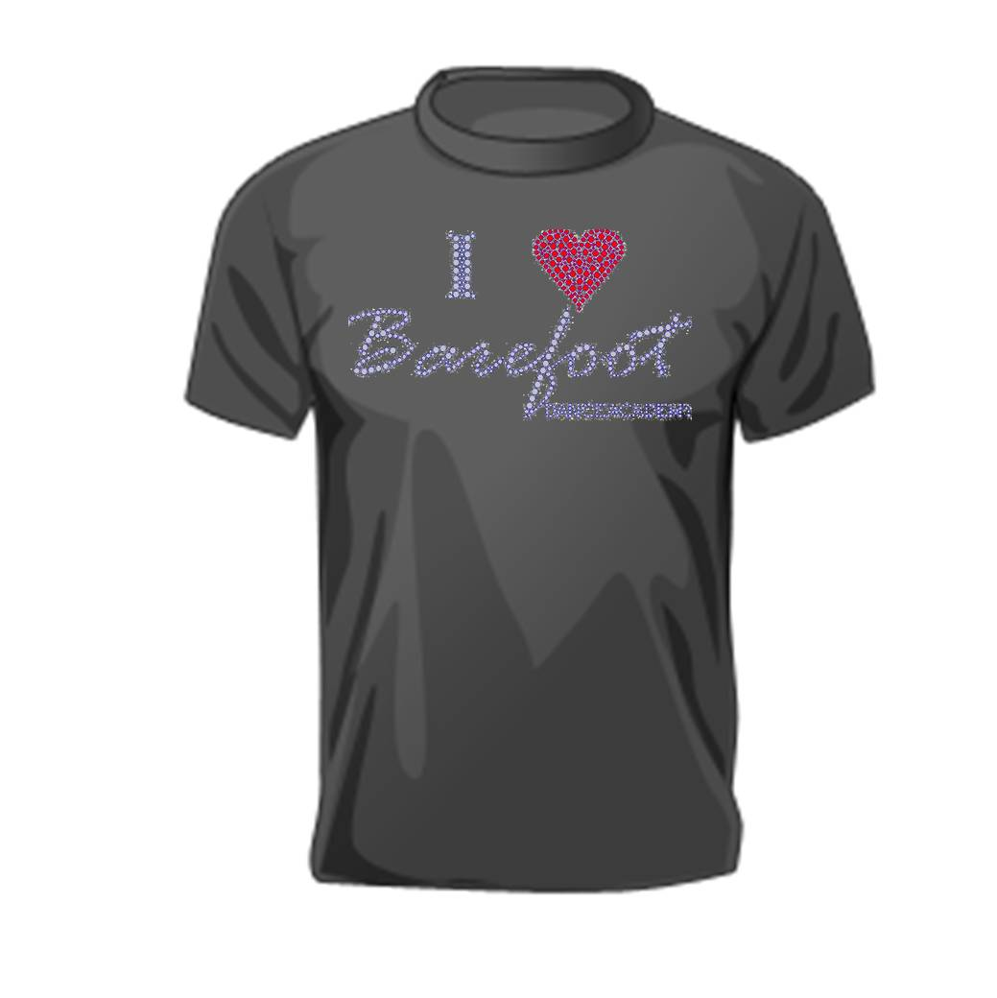

Party Information
Name of Birthday Child:
Last |  |  |  |  |  |  |  |  |  |  |  |  |  | First |  |  |  | Age
Address:
 |  |  | Street Address |  |  |  |  |  |  |  |  |  |  |  |  |  |  | Apartment/Unit #
 |  |  | City |  |  |  |  |  |  |  |  |  |  |  |  |  | State | ZIP Code
Home Phone: |  |  |  |  | ( ) |  |  |  |  |  | Date & Time Requested:
Number of Children Attending: |  |  |  |  |  |  |  | ________ (Final Count Must Be Given 5 Days Before Party)

Party Information
Please Note the following guidelines: The Party will be set up for the age of the Birthday Child. (The equipment height and activities may not be suitable for younger guest) Do not arrive more than 20 minutes prior to scheduled party time. Only the children attending the party must remain with the party staff at all times. All children attending the party must be listed on the party roster and have signed a waiver form for Insurance purposes.
The Party Parent and one helper may enter the studio area to video and take pictures. All other parents must remain in the designated viewing area for safety reasons. Adults are NOT permitted on the equipment.
Children classified with special needs may have a parent or aid to assist them. Due to possible allergic reactions, please do not serve any food containing nuts.
Is your child Currently enrolled in classes at Dance Studio 33?
 | Yes |  |  |  |  |  |  |  |  | No
Party Pricelist:
 | $185.00 |  |  |  |  |  |  |  |  | (For up to 10 Children)
 | $10.00 |  |  |  |  |  |  |  |  | Each additional child x _______ = $_________
Gender
 | Female |  |  |  |  |  |  |  |  | Male
Birthday Party Checklist (Provided by BNM)
 | Plates |  |  |  |  |  |  |  |  | Napkins
 | Cups |  |  |  |  |  |  |  |  | Spoons
 | Tablecloths |  |  |  |  |  |  |  |  | Decorations

- A $50.00 non-refundable deposit is required to reserve the party date and time.

- Parties are 45 minutes in the studio and 45 minutes in the party room. I understand that the party MUST end at the scheduled time. (You will be charged $25.00 for each 15 minutes of overtime in Party Room)

- I will provide an exact number of children attending the party, a minimum of 5 days prior to the date.

- Party guest must be in proper workout attire. (Comfortable Clothing)

- No food or beverages are permitted in our Studio Area. All food must be kept in Lobby.

- GRATUITIES ARE NOT INCLUDED and should be considered if deserved.

I understand the rules and guidelines listed above.

_____________________________ _______________
Print Name Date
_____________________________
Signature

For Office Use ONLY
$50.00 deposit: $________________
Balance due at Party: $____________
Number of Instructors Needed
__________________________ Names: _______________________________________________

